Member Newsletter

2022 No. 011

Dear Member/Student,

Welcome to the latest World Trichology Society newsletter.

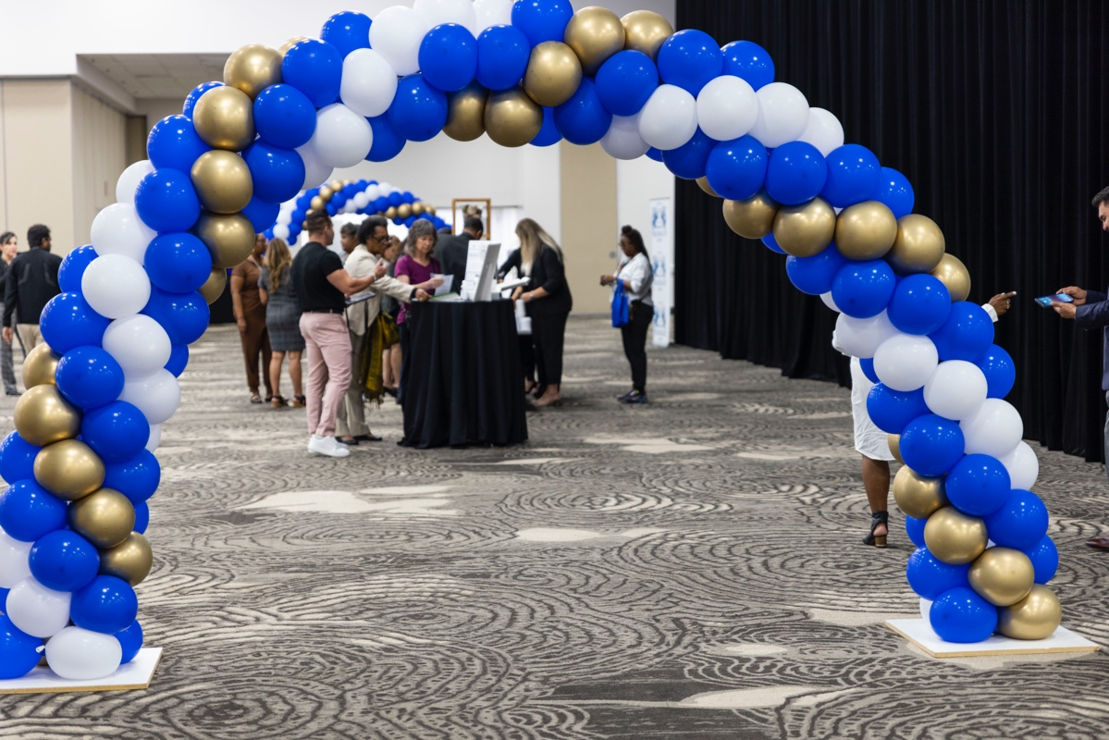

Current Trichological and Health News

1. Safety of minoxidil for hair disorders in pediatric patients
A retrospective review published in the International Journal of Dermatology evaluated the safety of systemic minoxidil, as either low-dose oral or sublingual, in 63 children aged 0-12 years with hair disorders. Two-thirds of patients were treated for alopecia areata and eight patients for loose anagen syndrome. Most patients started at a dose of 0.1 mg once daily, with dosage up-titrated according to treatment response. The average maximum dose concentration of minoxidil was 12.45 ng/kg, with a treatment duration range of three to 65 months. The mean duration of treatment was 14.6 months. Mild hypertrichosis was the most common side effect, although none of the side effects required discontinuation or dose adjustment. While low-dose oral minoxidil and sublingual minoxidil were well tolerated, the authors find that future prospective studies that objectively measure the efficacy and optimum dose concentration should be considered.

2. Type 2 diabetes and CCCA severity
A retrospective study published in JAAD examined whether a clinical association exists between the presence of type 2 diabetes mellitus and prediabetes and the severity of central centrifugal cicatricial alopecia (CCCA) in Black patients. The researchers found that of 35 patients with CCCA, 20 had type 2 diabetes or prediabetes — 15 patients did not. Of the patients who had diabetes or prediabetes, the average HbA1C was 6.93% compared to 5.26% in the control group. Patients with CCCA and diabetes/prediabetes had higher CCCA severity grades compared with controls. The average CCCA severity grade in the diabetes/prediabetes group was 3.16 versus 2.57 in the control groups. The authors suggest that a shared mechanism (peroxisome proliferator-activated receptor-γ) may be a marker of metabolic dysfunction.

3. Reduced post-infusion cooling prevents chemotherapy-induced alopecia
After research had shown that scalp cooling in patients treated with docetaxel could be reduced from 90 to 45 to 20 minutes, researchers sought to investigate whether the post-infusion cooling time (PICT) might be able to be reduced for patients treated with paclitaxel as well. The study, published in Supportive Care in Cancer, found that in patients treated weekly with paclitaxel, chemotherapy-induced alopecia (CIA) can be controlled as effectively with a 20-minute post-infusion cooling time (PICT) as with 45- or 90-minute PICT. Of the 38 patients in the 20-minute PICT group, hair preservation was accomplished for 82%, and of the 36 patients in the 45-minute PICT, hair preservation was accomplished for 75% — the same success rate for those with the standard 90-minute PICT (85%).

4. Unilever Recalls Dry Shampoo Products Over Concerns Of Elevated Benzene Levels
USA Today reports Unilever US “is recalling 19 dry shampoo aerosol products due to ‘potentially elevated levels’ of benzene, a chemical known to cause cancer in humans.” The voluntary recall “impacts select dry shampoo produced before October 2021 – including products from prominent Unilever brands like Dove, Suave and TRESemmé.” Unilever produced the affected products prior to October 2021. “Exposure to high doses of benzene, orally or through the skin, can raise the risk of certain cancers, including leukemia, as well as anemia and other serious blood disorders.”

5. Low-Dose Oral Minoxidil Appears To Have Positive Dose-Dependent Effect On Hair Diameter
Dermatology Advisor reports, “Low-dose oral minoxidil...has a positive dose-dependent effect on hair diameter, hypertrichosis, cardiovascular adverse events, and hair density in patients with androgenetic alopecia,” researchers concluded in a six-study systematic review and meta-analysis, the findings of which were published online in the journal Skin Appendage Disorders.

6. In Analysis, Researchers Characterize Willingness Of Patients With Alopecia Areata To Undergo Treatment
Dermatology Advisor reports that “most patients with alopecia areata (AA) reported that severe health risks are not acceptable when undergoing treatment, and stinging/burning is the only risk that most would tolerate, according to” researchers who “sought to characterize the willingness of patients with AA to undergo treatment via a secondary data analysis of a Burden of Disease Survey.” The findings published in the Archives of Dermatological Research also revealed that “the most acceptable treatment administration type was topical, with 74.18% of patients willing to accept it, and injection at site of hair loss was the least acceptable type of administration (44.66%).”

7. Five Classes Of Medication Most Associated With Hair Texture Changes
Healio reports “medication-induced hair texture changes are a potential side effect of various medications, according to a” 31-article systematic review. Investigators “concluded that there are five classes of medication that are most associated with hair texture changes:” Antineoplastic agents, antiepileptics, retinoids, immunomodulators, and antiretroviral therapy. The findings were published in the Journal of Drugs in Dermatology.

8. Majority Of Consumers Prefer Telehealth Over In-Person Visits For Wide Range Of Routine Care
Healthcare Finance News reports, “According to the newly released J.D. Power 2022 U.S. Telehealth Satisfaction Study, a growing majority of consumers now say they prefer telehealth over in-person visits for a wide range of routine care, including prescription refills, reviews of medication options and to discuss medical results.” Furthermore, “almost all – 94% – of telehealth users say they would use the technology to receive medical services in the future.” And “another 57% of patients say they prefer telehealth for regular mental health visits.”

9. Roflumilast Foam 0.3% Shows Promise In Phase III Trial For Treatment Of Adults And Adolescents With Scalp And Body Psoriasis
Healio reports, “Arcutis has announced positive topline results from the ARRECTOR pivotal phase 3 trial evaluating roflumilast foam 0.3% for the treatment of adults and adolescents with scalp and body psoriasis, according to a company press release.” The therapy “is a selective PDE4 inhibitor that has been formulated as an emollient, water-based, moisturizing foam that can be used on the scalp and body.” In this “trial, roflumilast showed high efficacy and safety ratings with 67.3% of subjects achieving Scalp-IGA success compared with 28.1% of individuals treated with vehicle.”

10. Serum 25-hydroxyvitamin D Deficiency Tied To Severity Of Chronic Plaque Psoriasis, Study Finds
Dermatology Advisor reports “a serum 25hydroxyvitamin D deficiency is associated with severity of chronic plaque psoriasis, the relationship inverse with a psoriasis area severity index (PASI) score, according to” a “case-control study” conducted in an “outpatient tertiary care clinic” in Nepal. The findingswere published in Psoriasis: Targets and Therapy.

11. Network Meta-Analysis Examines Patient, Protocol Factors Affecting Efficacy Of PRP Treatment For Androgenetic Alopecia
Healio reported, “Six patient and protocol factors were found to affect the efficacy of platelet-rich plasma [PRP] treatment on patients with androgenetic alopecia,” investigators concluded after “systematically reviewing 25 peer-reviewed studies with 10 unique PRP regimens.” The findings of the network meta-analysis and meta-regression study were published online in the Journal of Drugs in Dermatology.

12. Patients With Alopecia Areata Prefer To Make Treatment Decisions With Their Dermatologist
Dermatology Advisor reported, “Patients with alopecia areata...prefer to make treatment decisions with their dermatologist with use of shared decision making,” investigators concluded in the findingsof a 503-patient survey study published online in a brief report in JAMA Dermatology.

13. Lifelong Stress Associated With Increased Risk Of Cancer Death, Study Finds
HealthDay reports, “Over time, men and women under chronic stress face a significantly higher risk that they will die as a result of cancer, a new study” finds. Investigators found, “after adjusting for a number of influential factors...that lifelong stress appears to trigger a 14% rise in risk of cancer death.” The findings were published in Population Health.

14. Survey Study Examines Attitudes Of Patients With Androgenetic Alopecia Toward Minoxidil Therapy
Dermatology Advisor reports, “Minoxidil is an efficacious treatment with relatively few and mild side effects in patients with androgenetic alopecia,” but “significant barriers to minoxidil therapy include concern for life-long use, lack of effectiveness, and fear of side-effects, according to survey results” from 93 patients published online in a letter to the editor in the Journal of Drugs in Dermatology.

15. Regular Exercise May Improve Preventive Effect Of Coronavirus Vaccinations, Study Suggests
The Washington Post reports, “Regular exercise could amplify the benefits of your next coronavirus vaccination or booster...according to a...study of the effects of regular physical activity and vaccines.” The study published in the British Journal of Sports Medicine, “which involved almost 200,000 men and women in South Africa, found coronavirus vaccination effectively prevented severe illness in most of them. But it worked best in people who exercised regularly.” These people “wound up about 25 percent less likely to be hospitalized with COVID than sedentary people.”

16. Investigators Identify Potential Genetic Causal Link Between Smoking Behaviors, Psoriasis
Dermatology Advisor reported investigators have identified “a potential genetic causal link between smoking behaviors and psoriasis.” For the study, researchers compared “genetic variables about alcohol consumption (n=941,280), smoking initiation (n=1,232,091), cigarettes smoked per day (n=337,334), smoking cessation (n=542,219), and lifetime smoking (n=462,690)...with genetic instruments for psoriasis among 13,299 patients and 21,543 control participants in the test sample and 4510 patients and 212,242 control participants in the replication sample.” The findings of the Mendelian randomization study were published online in the British Journal of Dermatology.

17. Systematic Review And Meta-Analysis Examine Effectiveness Of Fractional Laser As Either Mono Or Adjunctive Therapy In Adults With Alopecia
Dermatology Advisor reported that “for adults with alopecia, combining fractional laser with another therapy is more effective than any other therapy alone, according to” a 13-study systematic review and meta-analysis that involved “patients with androgenic alopecia or alopecia areata undergoing fractional laser as either mono or adjunctive therapy.” The findings were published in the Journal of Cosmetic Dermatology.

Journal Articles
For journal publications, click on the URL under the title of the topic you wish to see and it will open to a free abstract of the article. For obtaining the full article, just follow the relevant prompts on the site (a payment may be required for the full article).

1. Analysis of alopecia areata surveys suggests a threshold for improved patient‐reported outcomes
Yael Renert-Yuval, et al.
https://onlinelibrary.wiley.com/doi/abs/10.1111/bjd.21696?

2. Transcriptomic analysis identifies regulators of the Wnt signalling and hypoxia‐inducible factor pathways as possible mediators of androgenetic alopecia
Michael Philpott
https://onlinelibrary.wiley.com/doi/full/10.1111/bjd.21881?

1. Comment on 'A prospective real world study evaluating serum levels of arginine and cysteine in females with chronic telogen effluvium: do we really need blanket prescription with amino acid supplementation?'
Ralph M. Trüeb, Natalia Caballero-Uribe, Ngoc-Nhi Catharina Luu, Angelina Dmitriev
https://onlinelibrary.wiley.com/doi/abs/10.1111/ced.15391?

1. Real‐World Experience and Long‐Term Evaluation of Tofacitinib in Refractory Alopecia Areata: A Prospective, Open‐Label, Single‐Center Study in Asian Arab Population
Husein Husein-ElAhmed MD PhD, et al.
https://onlinelibrary.wiley.com/doi/abs/10.1111/dth.15871?

2. Baricitinib as an effective treatment for Lichen Planopilaris
Zizhuo Li, Mengting Yin, Ning Xu, Xia Dou
https://onlinelibrary.wiley.com/doi/abs/10.1111/dth.15882?

3. Efficacy and safety of oral pioglitazone in the management of lichen planopilaris in comparison with clobetasol: a randomized clinical trial
Vahideh Lajevardi MD, et al.
https://onlinelibrary.wiley.com/doi/abs/10.1111/dth.15868?

1. The nit sheath: A rare histopathologic clue for the diagnosis of louse infestation
Zachary Theroux MD, Eric Hossler MD
https://onlinelibrary.wiley.com/doi/abs/10.1111/cup.14301?

2. Sebaceous gland atrophy in seborrheic dermatitis of the scalp; a pilot study
Neha S. Nagrani MD, Lynne J. Goldberg MD
https://onlinelibrary.wiley.com/doi/abs/10.1111/cup.14300?

1. Management of hair loss after severe acute respiratory syndrome coronavirus 2 infection
Manabu Ohyama, Kiichi Matsudo, Toru Fujita
https://onlinelibrary.wiley.com/doi/full/10.1111/1346-8138.16475?

2. Disrupted citric acid metabolism inhibits hair growth
Xiangguang Shi, et al.
https://onlinelibrary.wiley.com/doi/abs/10.1111/1346-8138.16509?

3. A case of telogen effluvium followed by alopecia areata after SARS‐CoV‐2 infection
Reiko Kageyama, et al.
https://onlinelibrary.wiley.com/doi/abs/10.1111/1346-8138.16590?

1. Alopecia due to hair extensions successfully treated with hair transplantation
Esmeralda Lopez MD, et al.
https://onlinelibrary.wiley.com/doi/abs/10.1111/jocd.15380?

2. A Cannabinoid Hairy‐Tale: Hair Loss or Hair Gain?
Aditya K. Gupta, Mesbah Talukder
https://onlinelibrary.wiley.com/doi/abs/10.1111/jocd.15427?

3. Efficacy and safety of tofacitinib for treatment of alopecia areata
Elham Behrangi, et al.
https://onlinelibrary.wiley.com/doi/abs/10.1111/jocd.15425?

1. Hair tourniquet syndrome: A retrospective study
Noa Martonovich MD, Maher Khatib MD, Michael Assaf MD
https://onlinelibrary.wiley.com/doi/abs/10.1111/pde.15151?

1. Comorbidities associated with lichen planopilaris: a case–control study using the All of Us database
Tejas P. Joshi BS, et al.
https://onlinelibrary.wiley.com/doi/abs/10.1111/ijd.16433?

2. Annular plaque over the scalp with patchy alopecia
Apoorva Sharma MBBS, et al.
https://onlinelibrary.wiley.com/doi/abs/10.1111/ijd.16442?

1. Mitochondrial dysfunction: The pathological link between psoriasis and insulin resistance?
A Villarreal-Martinez, et al.
https://onlinelibrary.wiley.com/doi/abs/10.1111/jdv.18631?

1. Shared Decision-Making, Therapeutic Choice, and Decisional Regret in Patients With Alopecia Areata
Sophia Reyes-Hadsall, BS; Lara Drake, BA; Jane J. Han, BS; et al.
https://jamanetwork.com/journals/jamadermatology/fullarticle/2795016?

1. Systematic review on skin adverse effects of important hazardous hair cosmetic ingredients with a focus on hairdressers
Wolfgang Uter, et al.
https://onlinelibrary.wiley.com/doi/abs/10.1111/cod.14236?

QUESTION FOR CTE® CREDIT (FOR MEMBERS ONLY): PLEASE EMAIL ANSWER TO:
INFO@WORLDTRICHOLOGYSOCIETY.ORG
In Shi et al.'s research article regarding " Disrupted citric acid metabolism inhibits hair growth", what was evaluated to investigate the role of Citric Acid metabolism in hair growth?

©2022 World Trichology Society
www.WorldTrichologySociety.org
Email: info@WorldTrichologySociety.org
T: 1-718-974-4242

